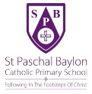
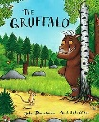
Expressive Art and Design:
As artists, designers and musicians:
Children will follow the Charanga Music unit – Me!
Children will be introduced to our favourite five songs and rhymes. Using props and figures, children will begin retelling stories using story telling language, vocabulary and repeated refrains they have learnt from the books we have read in different areas of the classroom. Children will use mirrors to observe their features. They will then use pencils too draw curves and lines to complete an observational drawing of themselves. They will also paint a self-portrait of themselves to display in our classroom. Using malleable materials and media, children will design and create their own Gruffalo monster. They will also follow a recipe to make and decorate Gruffalo oaty biscuits! Children will learn about printing, using autumnal objects to explore rubbing and printing.

Gruffallo oaty biscuits
Understanding the world:
As geographers, historians, scientists and technologists:
Children will be introduced to a timeline to show their time from birth to starting school. Using photos, children will talk about their past, for example their time at nursery. Children will learn about a family tree and create their own to show their family history.
Children will explore maps of our school and the local area. They will learn how to sketch maps of our school as they familiarise themselves with their new learning environment.
Children will learn about their bodies, identifying body parts and looking at ways to look after our bodies.
Children will learn that there are four seasons with a focus on Autumn. They will learn about and observe the changes during Autumn.
ICT: Barefoot Computing – Awesome Autumn
Religious Education: Come and See
As believers:
Children learn about our school mission statement ‘Following in the footsteps of Christ’. They learn how to make the sign of the cross and our school prayers that we say throughout the day.
Myself - Children will learn that we are all different and unique. They will talk about their feelings and experiences and recognise that God loves them. They will learn the importance of their Christian name and their family name.
Baptism - Children will learn that they are welcomed into God’s family through Baptism. They will talk about the stages of a Baptism and will recognise religious signs and symbols used in Baptism such as the font and Holy water.

EYFS Overview – Autumn One
Myself and Authors

Other
PSHE/RSE My Life Programme: All about me and Friendships
Journey of Love: Explore being special and unique, recognising difference, learn the joy of being a special person in my family and celebrating the joy of being in God’s family.
Sustainable Development: We will learn about sustainability and how we can be sustainable in school.
Mathematics:
As mathematicians:
Children will be introduced to the Maths-No Problem! Programme. The spiral approach to learning introduces key mathematical concepts which are revisited and built upon throughout the year.
The focus of this half term is matching, comparing, sorting and ordering quantities up to 10 in different contexts. To develop a deep understanding of numbers up to 10, children will explore counting, finding, comparing and identifying representations of amounts, they will also be exploring patterns within numbers to 10.
Maths for life:
Children will be introduced to the class calendar, discussing the day, date and month at register time. They will count how many children are in each morning, counting to the stopping number.

Literacy:
As readers and writers:
Children will be introduced to the Read Write Inc, phonics scheme which includes exposure to common exception words. By the end of the half term, children will be in a differentiated group matched to their phonic ability.
Children will practise reading and writing their first name. They will give meaning to the marks they make and begin to form recognisable letters. They will learn to hear and write initial sounds in words. Children will learn about labels and label pictures with initial sounds. They will learn about an author with a focus on Julia Donaldson. Using ‘The Gruffalo’ and ‘Room on the Broom,’ children will develop their story telling language, begin to hear a rhyming string and join in with simple repeated refrains.

Communication and Language:
As speakers and listeners:
Children will begin to focus their attention during small group and whole class activities. They will respond to simple instructions such as sitting in their carpet space, answering to their name during register time and begin joining in with prayers. Through stories, listening games and partner work (my turn, your turn) children will begin to develop listening skills, storytelling language and new vocabulary.

Children will talk about their interests and share their opinions. Using past, present and future tenses such as yesterday, today and tomorrow, they will talk about themselves, their friends and families in relation to their own experiences.

Personal, Social and Emotional Development
As class members:
Children will be introduced to our behaviour scheme ‘Race to Space.’ They will learn and begin to follow our school rules, becoming aware of the boundaries and behavioural expectations of our setting. Children will be introduced to our class charter and learn about being a rights holder, linked to Rights Respecting Schools.

Children will begin to settle into their new learning environment and daily routines. They will begin to make new friendships and become more outgoing towards unfamiliar people, building relationships with their teachers and other members of staff such as lunch time staff. Children will manage their self-care independently., going to the toilet and washing their hands.

Physical Development
As athletes:
Children will follow a progressive physical education programme through Little League.
Gross motor – Children will use large ribbons to make clockwise and anticlockwise movements. They will attempt to put their shoes, jumpers, cardigans and coats on without support. Children will attempt to hold a knife and fork to cut their food up independently.
Fine motor – Using large paper, chunky chalks and chunky pens, children will give meaning to the marks they make. Tools such as tweezers, pegs, threading and play dough will be used to strengthen muscles in hands ready for writing.
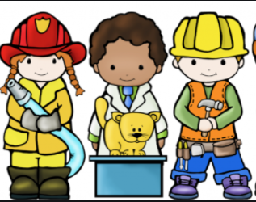

Chi
Religious Education: Come and See
As believers:
Advent – Children will talk about their feelings as they await a birthday and how they celebrate their birthday. They will learn that Advent is a time when we prepare to celebrate Jesus’ birthday. They will share ways in which they prepare for Christmas, as well as learning about the Advent wreath.
Children will listen to and sequence the Nativity story. They will take part in a Nativity play using narration, songs and dances to retell this story which is shown to the children in school and to their families.
Children will take part in regular collective worship and begin to show an understanding of reverence and respect during worship. Children will learn and begin to recite the Hail Mary prayer.
Other
PSHE/RSE My Life Programme: Staying Safe and What People Do All Day
RRS: Children will learn about the UN Convention on the Rights of the Child, completing weekly activities.
Sustainable Development: Children will learn about recycling and how they can recycle over the Christmas period.
Community: Children will take part in a ‘Santa Dash’ to raise money for our school community.
Physical Development
As athletes:
Children will follow a progressive physical education programme through Little League.
Gross motor – In our outdoor area, children will experiment with different ways of moving and move more energetically when running, jumping, hopping, skipping and climbing.
Fine motor – Activities such as unbuttoning shirts and transferring coins will be used to strengthen muscles in children’s hands. Children will be given straight lines, wavy lines and zig zag lines to trace, copy and attempt to cut to develop pencil grip and scissor control. Children will be shown how to zip their coats and be encouraged to try this independently when putting their coats on for outdoor play.
EYFS Overview - Autumn Two
People Who Help Us/Superheroes and Advent
Personal, Social and Emotional Development
As class members:
Children will be introduced to the whole school ROAR mental health programme which supports mental health through age-appropriate conversations and activities. Children will be encouraged to talk about how they feel, they will learn about being resilient.
Children will begin to understand right from wrong and explain the reasons for rules. They will begin to show sensitivity to their own and to others’ needs and feelings. Children will have developed confidence to ask adults for help and engage with others during play. When playing in a group, they will begin to extend and elaborate their own ideas. Children will learn about bonfire safety and the importance of eating healthily. They will be encouraged to try new foods at lunch time.
Communication and Language:
As speakers and listeners:
Children will continue to be introduced to new vocabulary through topic books including Supertato, Cops and Robbers and Stick Man. Children will continue to hear a rhyming string and join in with repeated refrains. With modelling from adults in continuous provision, children will attempt to talk in full sentence and retell stories in their own words of which are familiar to them. Children will be encouraged to use new vocabulary they have learnt in their play. Children will also develop their looking skills. Using partner work and games, they will learn the importance of looking at someone when they are speaking. Children will also stand at the front of the class to talk in front of their peers.
Expressive Art and Design:
As artists, designers and musicians:
Children will follow the Charanga Music unit – Everyone
Using junk modelling and resources in the classroom, children will build cities which include a police station, school, hospital ect. Children will create their own superhero sharing their name and superpowers. Using fabric and fabric pens, children will design and make their own superhero cape for their mini me superhero which will be used to play.
Children will learn how to use oil pastels to fade colours to create a dark night sky with a city silhouette inspired by Claude Monet’s House of Parliament Sunset.
Children will make Advent wreaths, Christingles and Christmassy crafts such as cards for their families.
Literacy:
As readers and writers:
Phonics – Children will continue with the Read Write Inc.phonics scheme learning to read and write sounds, words and have exposure to common exception words.

Children will continue to practise writing their name and forming letters. They will focus on CVC words, with children hearing and writing the initial, middle and final sounds in words. Children will label pictures they draw with CVC words. Children will learn about a list, writing one-word underneath another and write a short list of what they would like from Father Christmas. Using the book ‘Cops and Robbers’, children will discuss characters traits and feelings, using freeze frames to show them. Children will begin to develop comprehension and inference skills by answering questions about the story.
Mathematics:
As mathematicians:
Children will continue working through the Maths-No Problem! Programme.
The focus of this half term will be time (day and night, ordering events, days and birthdays) and composition of numbers one up to five. Children will learn to automatically recall number bonds up to five. Children will also learn about positional language, explore 2D shapes and find 2D shapes within 3D shapes.

Maths for life:
Using different mathematical resources such as counters, cubes and balancing scales, children will vote for their chosen story to read at snack time. This will lead to discussions such as more or less, tallest and shortest, heaviest and lightest

Understanding the world:
As geographers, historians, scientists and technologists:
Children will learn about the people in our community who help us such as doctors, fire fighters and police. We have a special visit from Merseyside Police and children prepare questions to ask them about their roles. Children will learn that we live in a city called Liverpool. Using Google Maps, children will look at Liverpool and identifying symbols for a hospital, school, police station ect. and discuss how near/far they are from our school. Children will learn how the weather changes during seasons and why the days are shorter. Exploring light and dark, children will make dens and use torches to explore shadows. Children learn how Christmas is celebrated around the world both past and present.
ICT: Barefoot Computing – Winter Warmers


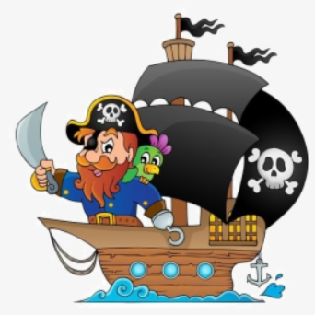
Other
PSHE/RSE My Life Programme: My World and Celebrations
RRS: Children will continue to learn about the rights of the child through planned weekly activities.
Sustainable Development: Children will learn about World Water Day and how to save and reuse water
Community: Children will celebrate Chinese New Year and World Book Day
Understanding the world:
As geographers, historians, scientists and technologists:
Children will use maps and atlases to explore and gain an understanding of the seven continents, where they are, their size ect. With a focus on Antarctica, children will learn compare similarities and difference of Antarctica and where they live. Children will learn about the lifecycle of an Emperor penguin. Children will take part in an ice investigation, they will make predictions and record their findings. Children will learn about the planets in our solar system. They will learn about famous astronauts and expeditions including the first man to land on the moon as show this on a timeline. They will also explore floating and sinking as part of our pirate topic.
ICT: Barefoot Computing – Boats Ahoy
EYFS Overview - Spring One
Our World and Beyond and Pirates
Personal, Social and Emotional Development
As class members:
Children will confidently follow class rules and routines. Children will demonstrate that they can take account of others and their ideas during play. They will engage with others during play and respect their perspectives. They will be able to take turns, share resources and if problems do arise, children will begin to negotiate and resolve them. Children will confident in a small group or during whole class carpet time to share their ideas and answers. Children will have well established, positive relationships with and strong friendships with their peers.
Using the ROAR mental health tools and the feelings wall, children will openly identify their own feelings and learn ways in which they can regulate them.
Literacy:
As readers and writers:
Phonics – Children will continue with the Read Write Inc.phonics scheme.
Using illustrations from Lost and Found, children will begin to write captions and understand that they have meaning. Children will learn about speech bubbles. They will compose and write speech to show how the characters are feeling in the story. Children will be introduced to non-fiction books about space and learn about their features. They will read and write simple facts about space and draw pictures to show their understanding. During our pirate topic, children will build on their story telling language and learn to read with expression using ‘The Night Pirates’. They will consolidate labels and captions by creating a wanted poster to describe Tom, the pirate who stole treasure!

Mathematics:
As mathematicians:
Children will continue working through the Maths-No Problem! Programme.
The focus of this half term is number and pattern. This will include visualising zero, adding and subtracting zero, counting forwards and backwards, racing outdoors, introducing a five frame and a ten frame, adding to five and then adding to ten, subitising up to five and sharing.
Maths for life:
Using large ten frames, children will add their counter to the tens frame as they come into class each morning. This will develop subitising skills and lead to discussions of more than or less than, comparing how many children are in from one day to the next.
Communication and Language:
As speakers and listeners:
When being read to, during whole class discussions and small group interactions, children will now listen attentively and respond to what they hear with relevant questions, comments and actions.
Children will understand how to wait their turn during a conversation with an adult or peer. Children will understand social ques such as expression, tone of voice and body language.
Children will confidently stand in front of the class and perform topic songs to their peers.
Children will continue to develop and apply new vocabulary from books they are exposed to including Lost and Found, On The Way Home, The Night Pirates and non-fiction about our world and space.
Physical Development
As athletes:
Children will follow a progressive physical education programme through Little League.
Gross motor - Using the resources in our outdoor area, the focus will be to develop running, skipping, hopping and jumping. Children will practise jumping on and off equipment with confidence and landing appropriately. Children will also travel with increasing confidence through balancing and climbing equipment.
Fine motor –. Children will continue to practise tracing, copying and cutting lines, patterns and shapes. Using thinner pencils and smaller paper, children’s drawings and writing will be more controlled and refined. Having plenty of practice, children will put coats and shoes on independently and cut up their own food at lunch time.

Expressive Art and Design:
As artists, designers and musicians:
Children will follow the Charanga Music unit – Our World. Children will learn and perform the ‘Continent song’ and the ‘Solar System song’ to recall the names of the continents and the planets, moving in time with the music using actions.
Children will develop sketching skills to sketch animals that live in Antarctica. Children will make finger puppets of the boy and the penguin from ‘Lost and Found’ which can they be used to retell the story and during play. Children will use junk modelling in out outdoor area to make space rockets and then use them to introduce a narrative in their play. Children will design a pirate ship and then use their design at home to make it. They will then share the process of making their pirate ship with their peers.
Religious Education: Come and See
As believers:
Celebrating – Children will share the different celebrations we celebrate throughout the year and how they feel being part of them. They will talk about how the parish family celebrate and will recognise the story of Mary and Joseph taking Jesus to the Temple to give thanks to God.
Gathering – Children will talk about times that they have gathered and how it made them feel. They will learn about the parish family and how and why they gather for Mass. Children will learn about the joy of gathering to celebrate Mass and attend whole school Mass. They will recognise some religious stories and the phrase ‘The Lord be with you and with your Spirit.’

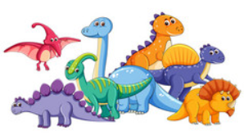
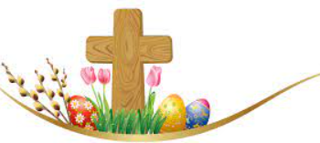
Other
PSHE/RSE My Life Programme: Looking after myself
RRS: Children will continue to learn about the rights of the child through planned weekly activities.
Community: Red Nose Day, children will take part in activities to raise money for Comic Relief

Personal, Social and Emotional Development
As class members:
Children will be able to select and use their own resources independently. They will enjoy the responsibility of carrying out small tasks.

Children will be able to describe themselves in positive terms, talking about their likes, interests and strengths.
Children will value themselves as individuals and begin to show resilience and perseverance in the face of challenge.

Children will be able to manage their own needs and feelings more independently. They will be familiar with the ROAR mental health rainbow and wall, and will them talk about their feelings using words such as upset, positive, calm, nervous and cross.
Understanding the world:
As geographers, historians, scientists and technologists:
Children will learn about Mary Anning, a fossil hunter who lived in the 1800s. They will make observations and comments about fossils. Children have talked about their own past and recent history and now they will use a timeline that goes ever further back to begin to develop an understanding of the past. Children will see where Mary Anning and dinosaurs are placed on a timeline.
Children will learn the names of different dinosaurs, comparing their similarities and differences. They will learn about dinosaurs which were carnivores, herbivores and omnivores and how we know this. Children will learn about how and why dinosaurs became extinct. They will also observe the world as it is today and compare it to when dinosaurs were alive using maps.
ICT: Barefoot Computing – Busy Bodies

Mathematics:
As mathematicians:
Children will continue working through the Maths-No Problem! Programme.
The focus of this half term is number and pattern and shape, space and measure. Children will continue to develop subitising skills, one more and one less up to ten, number bonds to ten, partitioning, recognising and creating patterns, using rulers, comparing heights, developing capacity language of empty, full, half-full, nearly full and nearly empty. Children will explore 2D shapes and 3D shapes including a cube, cuboid, cylinder and sphere.
Maths for life:
At snack time, the snack of the day will have a price.
This will lead to discussions with the children suggesting different ways to pay for the snack, coin recognition and working out how much change.
Literacy:
As readers and writers:
Phonics – Children will continue with the Read Write Inc.phonics scheme and be exposed to common exception words.
Children will consolidate their learning of the features of non-fiction using dinosaur books. They will be introduced to a biography and learn about fossil hunter Mary Anning. Children will read facts and recall what they have read about dinosaurs, Mary Anning and fossils. Children will write factual sentences about dinosaurs and fossils, applying new vocabulary to their writing.
Children will be confidently writing their name and their letter formation will be legible to themselves and to others. Children will be writing on lined paper with most letters balancing on the line.
Physical Development
As athletes:
Children will follow a progressive physical education programme through Little League
Gross motor – Children will develop their overall body strength, co-ordination, balance and agility through yoga. They will understand that yoga is good for their bodies and their minds. In our outdoor area, the focus will be to develop a range of ball skills including kicking, throwing and catching through planned, teacher led games and activities.

Fine motor – Children will have access to a range of fine motor activities in the continuous provision including cutting to develop scissor skills. They will continue to be shown how to hold their pencil, most children will be using the modified tripod grip.

Expressive Art and Design:
As artists, designers and musicians:
Children will follow the Charanga Music unit – Big Funk Bear.
Children will use primary coloured paints and explore mixing them to make secondary colours. They will use to colours to make patterns and explore symmetry.
Using watercolours, children will learn how to blend the colours to create a sunset scene. They will then add dinosaur silhouettes.
Children will follow a simple recipe to make salt dough. They will then use seashells, pebbles and other natural objects to make ‘fossil’ impressions into the salt dough. Children will make their own dinosaur masks. Through music and dance, children will move their bodies in different ways to a traditional stick dance, learning a simple dance routine. They will perform their ‘Dinosaur Stomp’ wearing their masks.

Religious Education: Come and See
As believers:
Growing – Children will learn that Spring is a time when things grow and Lent is a time when we grow in love to be more like Jesus. Children will make Lenten promises and share ways in which they have grown during Lent.
Children will listen to the Easter story and will be able to talk about what happened to Jesus on Good Friday and Easter Sunday.
They will learn that Easter is the biggest celebration of the Christian calendar and will share ways in which they celebrate Easter. Children will sing songs, make Easter baskets and Easter cards to share with their families.
Communication and Language:
As speakers and listeners:
Children will be able to sit, listen and focus for longer periods of time on the carpet and during a teacher led activity. They will be able to ask relevant who, what, where, why, when and how questions about the world around them. Learning about what life was like during the dinosaur period, children will use past and tenses when speaking about their findings.
Children will learn the meaning of new words for example carnivore, archaeologist and fossil.
Children will now be articulating their ideas and thoughts in well-formed sentences. They will be able to communicate with teachers and peers to talk about what they are doing, to organise their thinking, to take part in activities and to work out problems.

EYFS Overview - Spring Two
Dinosaurs and Lent/Easter
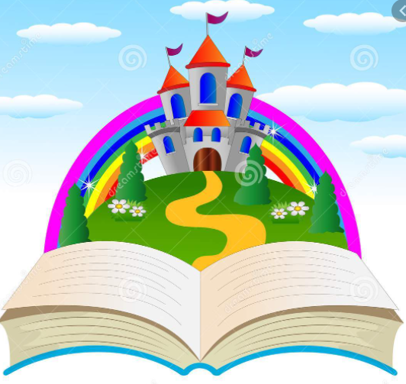
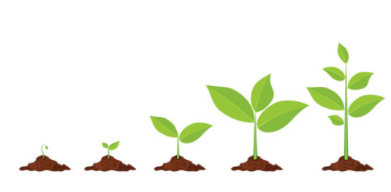
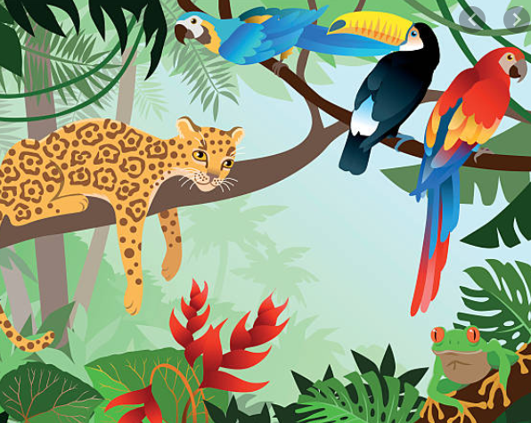

ICT: Barefoot Computing – Boats Ahoy
Other
PSHE/RSE My Life Programme: Being Healthy
RRS: Children will continue to learn about the rights of the child through planned weekly activities.
Community: Children will learn about our patron Saint Paschal Baylon and celebrate his Feast Day
School trip: As celebrate our growing topic, children will enjoy a day out at Farmer Ted’s Adventure Farm
Personal, Social and Emotional Development
As class members:
Children will be able to work and play cooperatively in continuous provision and at play time. They will be able to share, take turns and wait for what they want, controlling their immediate impulses when appropriate.

As part of our growing topic, children will learn about healthy foods and will be able to talk about where our food comes from, different food groups and identify which foods are good for them as part of a balanced diet. Children will be confident to try new foods including a fruit smoothie that we will make and drink!

Children will be able to regulate their emotions and feelings independently using tools within the classroom if needed. Children will begin to set and work towards simple goals.
Mathematics:
As mathematicians:
Children will continue working through the Maths-No Problem! Programme.

The focus of this half term will be counting, focusing on counting sequences, counting on a ten frame, counting on from any given number, counting backwards and counting to and from 20. We will also explore ordering numbers to 20, doubling, halving, sharing and odd and even numbers.

Maths for life:
Using books such as The Doorbell Rang, Baby Goes to Market, and One is a Snail and Ten is a Crab in continuous provision, children will complete a range of activities to develop their mathematical language, reasoning and problem solving.
Expressive Art and Design:
As artists, designers and musicians:
Children will follow the Charanga Music unit – My stories.
Children will learn about the artist Vincent Van Gogh. They will study his painting ‘Apples,’ then complete their own observational drawings of apples. Using brush strokes of warm yellow, orange, red and pink to paint the apples, followed by cool green and blue tones for the background. Children will learn about form, adding shadows to their apples to make them look 3D. Children will make fruit smoothies.
Children will construct with a purpose in mind, using different media and materials to make their own props, for example a wolf mask or beanstalk using pipe cleaners. Children will use their props during play to retell, adapt and invent traditional tales that are familiar to them.
Communication and Language:
As speakers and listeners:
Children will listen to a range of well-known traditional tales including Jack and the Beanstalk. Children will understand that tales have common vocabulary such as once upon a time and happily ever after, applying this in play. They will begin to identify other common features such as magic, talking animals and good vs bad. Children will learn that tales can be broken up into a beginning, middle and end. They will identify and talk about the key events in tales they have listened to.

Children will be able to give focused attention to what their teacher or peers say, responding appropriately even when engaged in an activity. They will show ability to follow instructions involving several steps.
Understanding the world:
As geographers, historians, scientists and technologists:
Children will learn about plants and what they need to grow. They will plant beans in school and place them in different areas of the classroom. Over time, they will observe and record what happens to the beans as part of an ongoing experiment, predicting and recoding their findings.
Children will plant sunflower seeds and take them home. They will look after their sunflowers so that they grow.
With a focus on caterpillars and butterflies, children will observe their life cycle and watch how caterpillars form into a chrysalis and then emerge as a butterfly.
Using maps, children will identify where types of butterflies live and how they survive.
ICT: Barefoot Computing – Springtime

Literacy:
As readers and writers:
Phonics – Children will continue with the Read Write Inc.phonics scheme.
At this stage, children will be able to identify if a book is fiction or non-fiction. Children will use non-fiction books to learn about life cycles of plants and animals. They will read and sequence simple sentences as well as draw and write sentences about the life cycles. We will revisit lists and then children will read and order simple instructions on how to plant a bean. They will then write a simple set of instructions on how to plant a seed. Children will complete a diary at home, observing and writing about what they see.
Children will create story maps of Jack and the Beanstalk. Then they will innovate the tale, writing in first person so that they become the main character. Children will be able to read their own writing back to an adult.
Religious Education: Come and See
As believers:
Good News – Children will share times when they have given or received good news and how it made them feel. They will listen to the story of Pentecost day and learn that Jesus kept to his promise and sent a friend, The Holy Spirit. Children will learn the importance of the Holy Spirit and how it is a force that we cannot see but we can feel in our hearts.
Friends – Children will share who their friends are, what they do with their friends and how their friends make them feel. They will learn that friends fall out and talk about what breaks and mends friendships. Through religious stories, children will learn that they are all friends of Jesus and what Jesus tells us about being friends and how to treat them.
EYFS Overview - Summer One
Growth and New Life and We Love Tales!
Physical Development
As athletes:
Children will follow a progressive physical education programme through Little League
Gross motor – Children will travel with confidence and be able to move in a range of ways. They will show good control and co-ordination in large and small movements. Children will have good spatial awareness when playing games and use their developing ball skills in team games such as football and dodgeball.
Fine motor – Children will continue to access fine motor activities. Their cutting skills, drawings and writing will be more defined. Children will be able to cut out shapes and pictures with increasing control. Children will be able to pour and transfer water with control. Their pencil grip will be developing into a tripod grip.
Communication and Language:
As speakers and listeners:
Children will participate in one-to-one, small group and whole class discussions. They will look at and listen to the person who is talking, responding to what is said with relevant answers and ideas. Children will sit and listen with sustained concentration to follow a story without pictures and during an assembly.
Children will have gained a wide range of vocabulary from stories, non-fiction, rhymes and poems which they will be able to apply. Children will use past, present and future tenses when speaking. When talking about the future, they will make use of conjunctions such as but and when to explain where they are going on holiday or what job they would like when they grow up.

Physical Development
As athletes:
Children will complete the physical education programme through Little League
Gross motor – Children will negotiate space and obstacles safely with consideration for themselves and others. They will demonstrate good strength, balance and coordination when playing and accessing the resources in our outdoor area. Children will take part in a whole school sports day linked to a major event e.g. The Olympics and apply a range of skills they have learnt during the year.
Fine motor - Children will be holding a pencil effectively (tripod grip) in preparation for fluent writing. They will show accuracy and care when drawing. Children will use small tools including scissors, paint brushes and cutlery both confidently and effectively.

Religious Education: Come and See
As believers:
Our world – Children will learn about the story of creation and how we came to be here. They will recognise words and phrases from a Psalm. Children will talk about the places that are special to them. Using CAFOD resources, they will learn about how wonderful God’s world is and share ways in which we can look after it. They will learn how children around the world look after our world too.
During ‘Other Faiths Weeks’, children will learn about Judaism, Hinduism, Islam and Sikhism. Children will know some similarities and differences between different religious and cultural communities in this country, drawing on their experiences and what has been read in class.

Other
PSHE/RSE My Life Programme: My Feelings and Growing Up
Sustainable Development: Children will learn about palm oil, deforestation and plastic pollution in the oceans
Community: Children will take part in a whole school Spanish Fiesta Day and a themed Sports Day
EYFS Overview - Summer Two
Holidays and Habitats
Personal, Social and Emotional Development
As class members:
Children will enjoy regular meditation, using breathing techniques and ear rubbing to bring calmness to themselves.
Children will reflect on their time in Reception, talking about how they have grown over they year. They will share what they have enjoyed learning and their favourite memories.
Children will talk about their feelings as they prepare to leave Reception. Children will begin the smooth transition into Year One. They will meet their new teacher, spend time in their new classroom and complete activities so that they become familiar and comfortable in their new learning environment. Children will have well established friendships.

Literacy:
As readers and writers:
Phonics – Children will continue with the Read Write Inc.phonics scheme. They will be reading and writing words and sentences matched to their phonic knowledge including some common exception words. Children’s writing will be legible and they will be able to read their own writing back to others. Children will be forming most, if not all numbers and letters correctly.
Children will learn about the layout and features of a postcard, they will read examples of postcards before writing their own.
Children will read ‘Giraffes can’t dance’, discussing the vocabulary and key events in the story. Children will learn about third person, then innovate their own version of the story, writing it in third person.

Understanding the world:
As geographers, historians, scientists and technologists:
Children will share photographs of where they have been on holiday in their past. Using maps, children will locate the places they have visited and talk about what these places were like, comparing their holiday environment to where they live now. Children will share where they would like to visit in the future and give reasons why.
Children will learn what a habitat is and look at different examples of habitats. They will learn about what plants, animals and birds live in these habitats and locate different habitats on a map. With the focus on a beach habitat, children will learn about the features and characteristic of a beach. They will explore how and why our habitats are changing.
ICT: Barefoot Computing – Summertime fun

Expressive Art and Design:
As artists, designers and musicians:
Children will follow the Charanga Music unit – Reflect, Rewind and Replay.
Children will collect a range of natural materials and together with materials in the classroom, use them to create a collage of a habitat such as a desert, rainforest, meadow or seashore. Children will talk about the process, what they like about their collage and if they would change anything.
Using junk modelling, children will use their imagination and gained knowledge to construct models with a purpose. This may be a mode of transport to go on holiday for example.
Children will learn songs and dances to perform in our end of year celebration assembly which will be shown to their families.

Mathematics:
As mathematicians:
Children will continue working through the Maths-No Problem! Programme.
The focus of this half term is to explore mass, using the language heavy and light to compare masses. Children will also explore the volume of liquids, comparing capacities. In addition, children will learn about money including coin recognition, sharing money and giving change. They will learn about pictograms and collect, interpret and record data. We will also revisit some key concepts in preparation for year one.

Maths for life:
Children will demonstrate and apply what they have learnt including skills, concepts and vocabulary during their play.

