
EYFS Book Rationale 2022-2023
TOPIC |  |  | BOOKS | OUTCOMES AND CURRICULUM LINKS
AUTUMN TERM | OUR TRANITION TO SCHOOL  AMAZING AUTHORS |  | 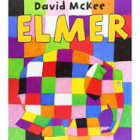  Elmer  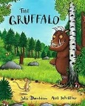  The Gruffalo  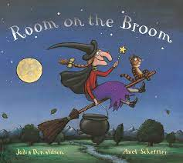  Room on the Broom | Talk through stories  Opportunities to explore our differences and discussion around characters feelings and our own feelings. Children will use facial expressions to explore how glum, gloomy, cheeky, playful, chirpy, cheerful may look. They will develop new vocabulary incl. unique, serious and gasped.  Talk through stories  Children will be introduced to a rhyming string, they will begin to join in with repeated refrains such as “silly old snake/fox/owl/ doesn’t he know, there’s no such thing as a Gruffalo!” Children will develop new vocabulary incl. wonderfully, frightfully, terrible, knobbly and poisonous.  Talk through stories  Children will continue to hear a rhyming string, completing rhyming sentences from the story. Children will be confident joining in with repeated refrains such as “I am a frog as clean as can be, is there room on the broom for a frog like me?” Children will begin to sequence the story by identifying the characters as they get on the witch’s broomstick. They will develop new vocabulary such as grinned, shrieked, clutched, magnificent, keen and grateful.
AUTUMN TERM | SUPERHEROES  PEOPLE WHO HELP US  CHRISTMAS |  | 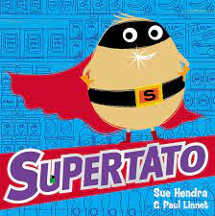  Supertato  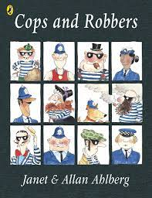  Cops and Robbers  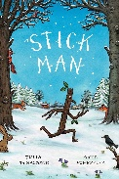  Stick Man | Talk through stories  Children will learn about characters and identify the main characters in the story (Supertato and Evil Pea), there will be opportunities for discussion around problems and resolutions with children beginning to identify these within the story. Children will begin to read with expression and be introduced to new vocabulary incl. escaped, rescued, distressed, vanished, crept, leapt and shrieked.  Talk through stories,  Children will identify the main characters in the story and discuss their character traits. We will revisit problems and solutions as well as exploring good and bad in the story. Using freeze frames, children will show how the characters are feeling in different parts of the story and begin to explain why. We will revisit rhyming and repeated refrains with children using expression to say “ho, ho for the robbers, the cops and the robbers, ho ho!” Children will be introduced to new vocabulary incl. dreadful, prowl, rumpled, whirled and skidded.  Talk through stories  Children will identify the main characters and problem in the story. They will discuss how the characters are feeling and use freeze frames to show this. Children will revisit rhyming, confidently identifying the rhyming words in the story and using expression, join in with the repeated refrain “I’m not a stick, why can’t you see, I’m stick man, I’m stick man, I’m stick man that’s me, and I want to go home to my family tree”. Children will be introduced to new vocabulary incl. twirling, tumbling, shoved, weary, chuckling, dozing and clattering.
SPRING TERM | OUR WORLD AND BEYOND  PIRATES | 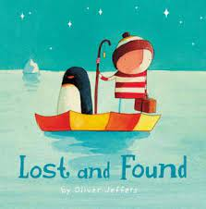  Lost and Found  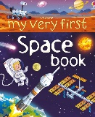  Space (Non-fiction)  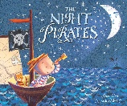  The Night Pirates |  | Talk through stories  Children will identify the main characters and use freeze frames to show how the boy and penguin are feeling in different parts of the story. There is no speech in the book, children will be given the opportunity to compose their own speech, thinking about what the character might say to each other. Children will learn about illustrations and use them to add their speech using a ‘speech bubble’. Children will be introduced to new vocabulary incl. ignored, disappointment, discovered and delighted.  Children will be introduced to non-fiction, learning that non-fiction is real/factual whilst fiction is imaginary/made up. Children will learn about the key features of non-fiction incl. contents page, headings, photographs, labels and a glossary and begin to identify these features. Children will learn simple facts about space, recalling the information they have heard. Children will comment and ask relevant questions about space, using the space non -fiction book to find the answer. Children will learn the meaning of new words such as solar system, comet, astronaut, asteroid, launchpad and spacecraft.  Children will identify the main characters and their traits. They will use freeze frames to discuss and show how the characters are feeling in the story. Children will use storytelling phrases and actions such as next, then and after that to retell the story independently. Children will practise retelling the story using expression. Children will begin to infer information from the book and will use the illustrations to describe what the characters look like. Children will be introduced to new vocabulary incl. stealthy, disguise, strange, gaped and goggled.
SPRING TERM | DINOSAURS | 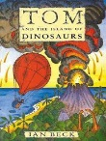  Tom and the Island of Dinosaurs  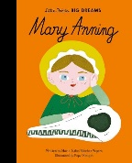  Many Anning (Biography)  Dinosaurs  (Non-fiction)  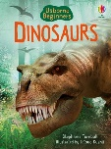 |  | Children will identify the main characters and they will use freeze frames to discuss and show how the characters are feeling in the story. Children will use storytelling phrases and actions such as next, then, suddenly. after that and at that moment to retell the story independently. Children will identify the speech in the story and practise retelling it using expression. Children will infer information from the book and discuss what they could reply to the letter. Children will be introduced to new vocabulary incl. glinting, shipwrecked, enormous, tether, soared and perched.  Children will be exposed to another text type, a biography. They will learn that a biography is an account of someone’s life that is written by someone else. Children will learn about the features of a biography and listen to the biography of Mary Anning before answering questions about her. Children will learn the meaning of new vocabulary incl. miraculously, curiosity, fossil, passion, discovery, contribution and palaeontology,  Children will revisit non-fiction. Children will be able to explain that non-fiction is real/factual and identify some features. Children will listen to and recall simple facts about dinosaurs and fossils and write sentences to show their learning. Children will also comment and ask relevant questions about dinosaurs and fossils, using the dinosaur non-fiction book to find the answer. Children will learn the meaning of new words such as scaly, snout, claw, prey, herd and hatch.
SUMMER TERM | GROWTH AND NEW LIFE  TRADITIONAL TALES |  | 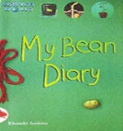  The Bean Diary  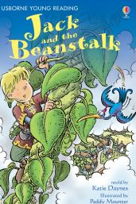  Jack and the Beanstalk  The Last Wolf  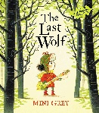 | Children will confidently identify that The Bean Diary is a non-fiction book by recognising key features incl. the contents page, photographs, headings and labels. Children will be able to use their phonic knowledge and knowledge of common exception words to read and understand the sentences in the book. Children will begin to sequence what they have read and show understanding by planting their own beans and completing diaries. The knowledge children gain from reading this book with support them when writing a set of instructions about planting a bean.  Children will be introduced to traditional tales and learn that a traditional tale is a well-known story that has been told again and again for many years. Children will learn the common vocabulary in traditional tales such as once upon a time and happily ever after, applying this in play when retelling or creating their own stories. Children will begin to identify other common features such as magic, talking animals and good vs bad. Children will learn that tales can be broken up into a beginning, middle and end. They will identify and talk about the key events in Jack and the Beanstalk then complete story maps to show their understanding. Through modelling and support, children will innovate Jack and the Beanstalk, writing the story about themselves. Children will learn about first person and write in first person their own version of the tale, who do they meet at the top of the beanstalk and what happens to them?  Children will have had exposure to lots of traditional tales as part of our topic. The Last Wolf is a twist on a classic traditional tale, Little Red Riding Hood. Children will learn about the threat of extinction as forests are decreasing and there is less food for animals to eat. Children will identify the main characters and talk about their feelings at different points of the story. They will identify the problems and the solution. Children will be introduced to new vocabulary incl. lurked, pounced, bracken, whooling and grabby. This book feeds well into our next topic about palm oil, deforestation and sustainability giving children some prior knowledge.
SUMMER TERM | HABITATS  HOLIDAYS |  | 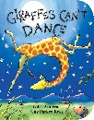  Giraffes Can’t Dance  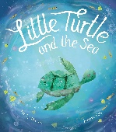  Little Turtle and The Changing Sea  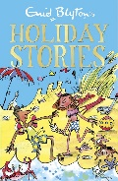  Holidays | Children will be confident identifying that this text has rhyming words in it. Children will discuss the main characters in the story and use freeze frames to show how they are feeling at different points. Children will identify and sequence the main events in the story and answer questions about it. With modelling and support, children will innovate the story and learn about writing in third person. They will use their newly gained knowledge and vocabulary from the story to change the character and the action, for example ‘Lions can’t jump’. Children will be introduced to new vocabulary incl. awfully, crooked, buckled, pranced, splendid and sneered.  This text links to our ‘Habitats’ topic and sustainability focus of looking after life below water. This story educates children about plastic pollution and its dangers to our oceans and wildlife and opens up lots of discussion around the issue. Children will identify the problem and solution and discuss how the turtle feels at different points in the story, explaining why. Children will be introduced to new vocabulary incl. rumbled, currents, content, outgrown and foraging. Children will use their knowledge from the story to complete activities and share the important message about plastic pollution with their families and friends.  This book has a range of short stories such as ‘The Magic Ice Cream’ and ‘The Donkey on the sand’. Children will sit for longer periods of time and follow a story without visuals, using their imagination to bring the story to life. Children will identify the characters and key events in each short story. They will answer questions about the stories to develop their comprehension skills. The ideas and vocabulary they gain from listening to the stories will be applied when the children write their own postcards, imagining that they are on holiday describing where they are and what it is like.

